Major Project Report

On

**Ai Chat Bot for Polytechnic College Counselling**

Submitted in Partial Fulfillment for the Award

Of

Diploma in Computer Science Engineering (2021-22)



**RAJIV GANDHI PROUDYOGIKI VISHWAVIDYALYA BHOPAL (M.P.)**

Submitted

By

**Abhishek Dwivedi**

Under the Supervision

of

**Mr. Mahendra Gupta**



**GOVERNMENT POLYTECHNIC COLLEGE ANUPPUR**

**MP-484224**

# 

# Certificate

This is to certify that project entitled **“Ai Chat Bot for Polytechnic College Counselling ”** is being submitted by **Mr. Abhishek Dwevidi** to the **Dept. of Computer Science and Engineering, Govt Polytechnic College Anuppur, M.P.-484224, India**, in the partial fulfilment of the requirements for the award of the diploma in **“Computer Science and Engineering”**. This work is carried out by himself in the Dept. of Computer Science and Engineering under the supervision of **Mr. Mahendra Gupta.** The matter personified in the project report has not been submitted for the award of any other degree or diploma.

Mr. Mahendra Gupta

(**Supervisor**)

Mr. Utkarsh Agrawal

(**HoD**)

Mr. Raju Singh Paraste

(**Principal**)

Contents

Certificate 2

Table of Content 4

3. DECLARATION 5

5. INTRODUCTION 7

6. OBJECTIVE 8

7. FLOW CHART 9

8. HARDWARE REQUIREMENT 10

8. SOFTWARE REQUIREMENT 10

8.1 VS CODE 10

8.2 PYTHON 10

8.3 RASA FRAME WORK 10

8.4 INSTALLING PROCESS OF RASA:- 10

9. WORKING 11

9.1. Actions 12

9.1. DATA:- 13

9.2. NLU.yml:- 13

9.3. STORIES.yml:- 14

9.4. RULE.yml:- 15

9.5. MODEl:- 16

9.6. CONFIG.yml:- 17

9.6.1 PIPELINE:- 18

9.6.2 Tokenizers:- 18

9.6.3 FEATURIZERS:- 20

9.6.4 Intent Classifiers:- 20

9.6.5 Entity Extraction:- 21

10. credentials.yml:- 22

11. Domain.yml:- 22

12. Process to Insert Chatbot in Website:- 23

13. Process to make Whatsapp bot using rasa:- 24

Stpes to make Whats App Chat bot:- 25

14. REFERENCES:- 28

# Table of Content

1. Cretificate………………………………………………………………………………………………………………………….1
2. Content of Table………………………………………………………………………………………………….…………….2
3. Declaration……………………………………………………………………………………………………………..…………3
4. Acknowlegement…………………………………………………………………………………………………………………4
5. Introduction………………………………………………………………………….…..………………………………..…….5
6. Objective………………………………………………………………………………………………………………………..….6
7. Flow Chart…………………………………………………………………………………………………………………..…….7
8. Hardware/Software requrement……………………………………………………………………………………….8

8.1 VS Code…………………………………………………………………………………………………8

8.2 Python………………………………………………………………..………………………………….8

8.3 Rasa Frame Work……………………………………………………………………………….….8

8.4 Installing Process of Rasa……………………………………………………………..………..9

9) Working………………………………………………………………………………………………………………………………10

9.1 Action………………………………………………………………………………………………………11

9.2 Nlu……………………………………………………………………………………………………..…..12

9.3 Stories…………………………………………………………………………………………………….13

9.4 Rule………………………………………………………………………………………………….…….14

9.5 Model…………………………………………………………………………………………………….15

9.6 Config……………………………………………………………………………………………..….….16

9.6.1 Pipeline……………………………………………………………………………………………….16

9.6.2 Tokenizer…………………………………………………………………………………………….17

9.6.3 Intent Classifiers…………………………………………………………………………….…....18

9.6.4 Entity Extraction…………………………………………………………………………………..18

10) Crendital……………………………………………………………………….……………………………….…………….…..…. 19

11) Domain…………………………………………………………………………………………………………………………….…….20

12) Process of insert bot in website………………………………………………………………………………….……..…..21

13) Process of make WhatApp chatbot……………………………………………………………………………….…….....22

14) Refrence……………………………………………………………………………………………………………………….…………27

# 3. DECLARATION

We hereby declare that the work which is being presented in the project report

Fulfilment of the requirement of the “Diploma in Computer Science” branch is

Authentic record of our work carried out the guidance of “Mr. Mahendra

Gupta(lecturer)”.

The work has been carried out at Govt. Polytechnic College Anuppur(M.P.)

**PROJECT ASSOCIATES: -**

ABHISHEK DWIVEDI

**4. AKNOWLEDGEMENT**

A project this like one involves many people and in would complete without the mention of all those people whose guidance and encouragement helped in the successful completion of this project.

Our heartily thanks our faculty member of Department of Computer Science Govt. Polytechnic College Anuppur for their efforts towards our project.

We would like to thanks our project in charge Mr. Mahendra Gupta who has been great source of inspiration for us and without whose humble guidance of project was never to shape.

We are also indebted to our guide Mr. Mahendra Gupta for the Encouragement Guidance and Support.

We are also thankful to all many people whose timely help out paucity of space is restricting us from their name.

And finally, we also thanks to all my college who were constant support during the whole project.

**PROJECT MEMBER:-**

ABHISHEK DWIVEDI

# 5. INTRODUCTION

I’m sure each of us would have interacted with a bot, sometimes without even realizing! We are in the era of Conversational AI now. Every website uses a Chat bot to interact with the users and help them out. This has proven to reduce the time and resources to a great extent. At the same time, bots that keep sending” Sorry I did not get you ” just irritate us. You need to ensure that the performance is satisfactory too.

Rasa open source provides an advanced and smooth way to build your own chat bot that can provide satisfactory interaction.

We can put RASA Chatbot your website and connect to the database after that RASA will manage the user coming to our web site like this:-

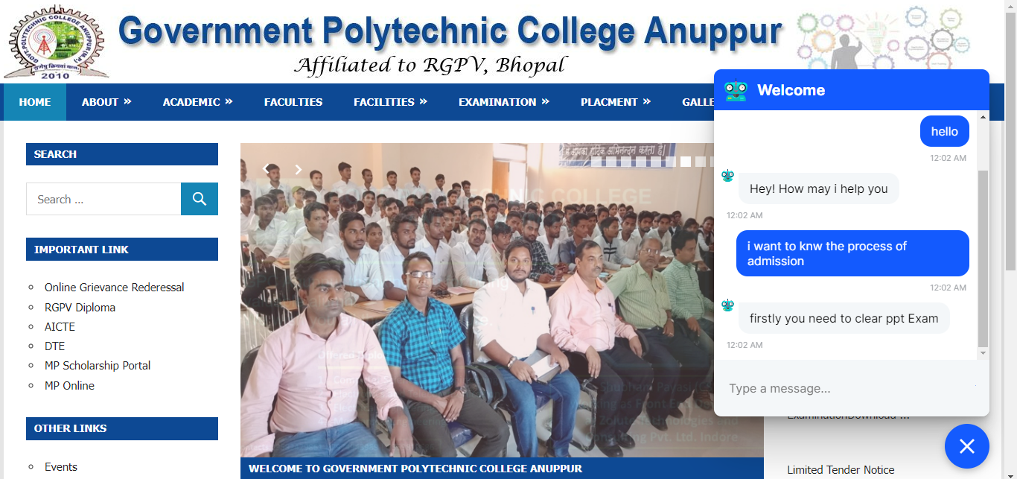

And with this we can also make a Bot for **WhatsApp** like this: -

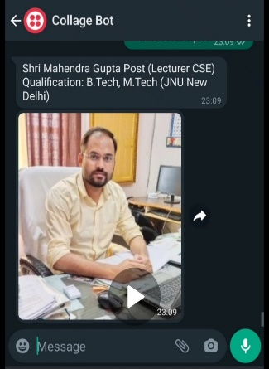

# 6. OBJECTIVE

A chatbot can communicate with a real person behaving like a human.

Let’s list down objectives and purpose of chatbots.

You can create chatbots for any business the same as you recruit a person for any department of your company. Whether you are a:

1. Wedding Planner
2. Insurance Assistant
3. Education Consultant
4. Legal Assistant
5. A real estate business
6. Recruiter
7. Travel Agency
8. Hospital or a Beautician!

The difference is that a customer support staff can only give support services whereas a Bot can help in doing all-in-one services. From acquiring users from comments to taking them to the messenger and at the end, making that user, your customer!

# 7. FLOW CHART

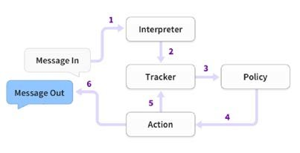

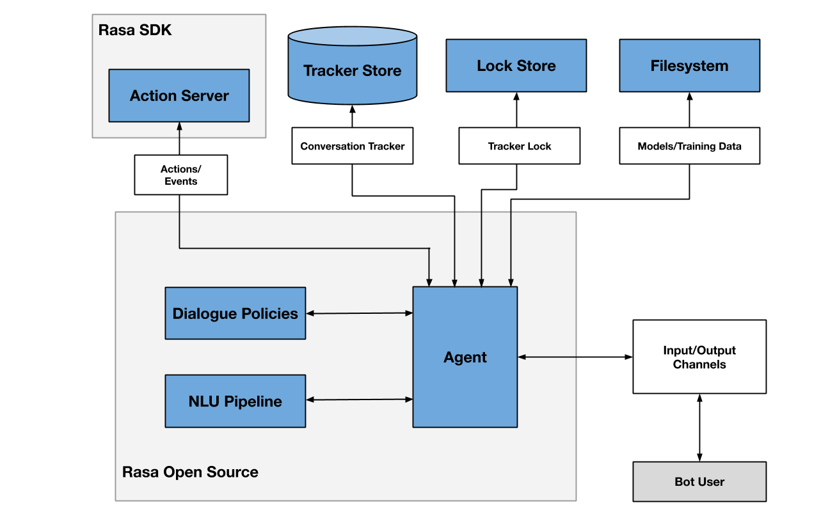

# 8. HARDWARE REQUIREMENT

**PROCESSOR**  i3

**RAM** 8GB

**STORAGE** 512 GB

# 8. SOFTWARE REQUIREMENT

**IDE**  Vs Code

**LANGUAGE** Python

**FRAME WORK** Rasa Frame Work

## 8.1 VS CODE

Visual Studio Code is a lightweight but powerful source code editor which runs on your desktop and is available for Windows, macOS and Linux. It comes with built-in support for JavaScript, TypeScript and Node.js and has a rich ecosystem of extensions for other languages (such as C++, C#, Java, Python, PHP, Go) and runtimes (such as .NET and Unity)

## 8.2 PYTHON

Python is an interpreted, object-oriented, high-level programming language with dynamic semantics. Its high-level built in data structures, combined with dynamic typing and dynamic binding, make it very attractive for Rapid Application Development, as well as for use as a scripting or glue language to connect existing components together.

## 8.3 RASA FRAME WORK

Rasa is a framework for developing AI powered, industrial grade chatbots. It's incredibly powerful, and is used by developers worldwide to create chatbots and contextual assistants. In this project, we are going to understand some of the most important basic aspects of the Rasa framework and chatbot development.

## 8.4 INSTALLING PROCESS OF RASA:-

To install rasa , you just have type a simple command **‘ pip install rasa’.**

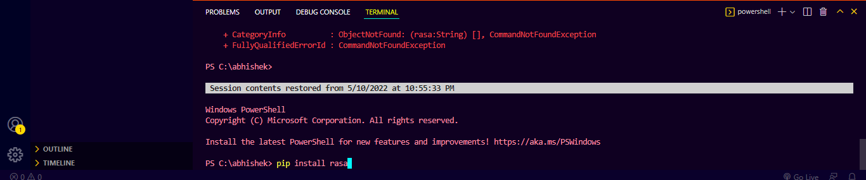

After that your rasa frame work will start installing

# 9. WORKING

When we install Rasa Framework, we get some preinstalled files and folders these are:-

Action, Data, Model, Domain.yml, Endpoint.yml, Config.yml and credentials.yml

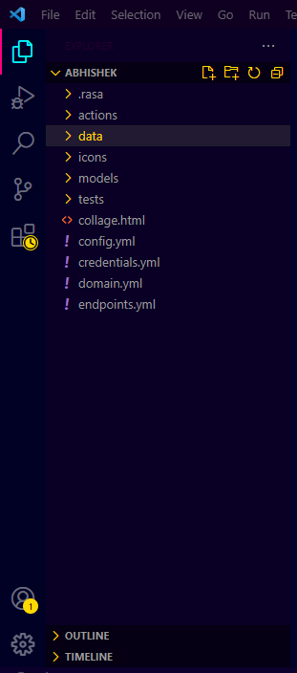

## 9.1. Actions

Action is a folder where we get action.py file it’s a Python , Which we use to do things like fetch data from API, to fetch data from database etc.

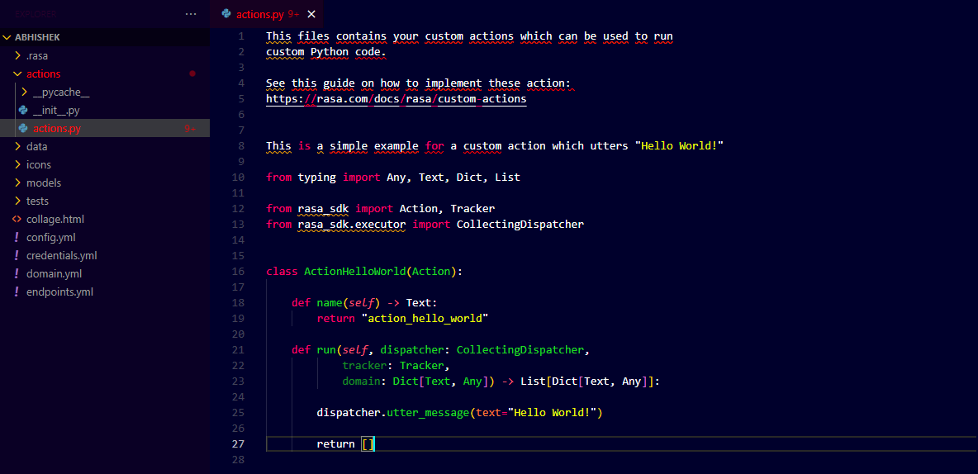

## 9.1. DATA:-

Data is a folder inside which we get some files like Nlu.yml,Rule.yml,Stories.yml

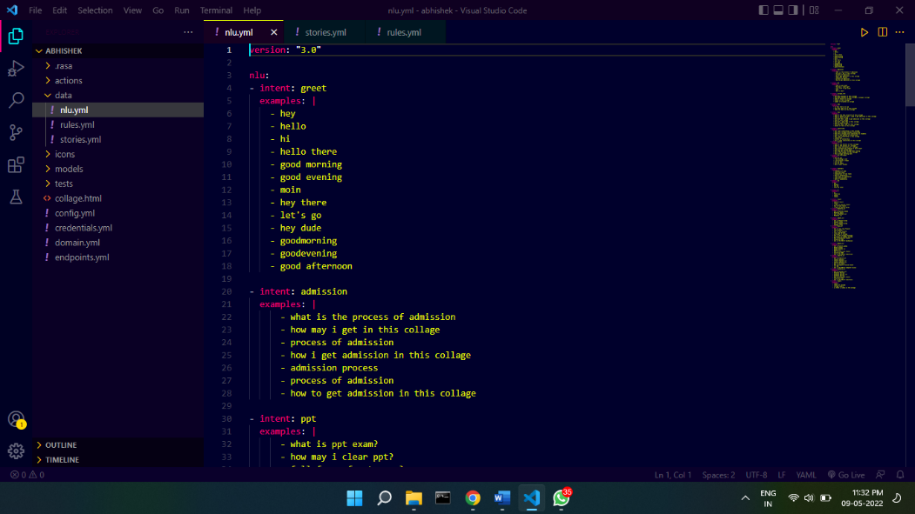

## 9.2. NLU.yml:-

Nlu is a file where we train your bot here we specify **Intent** and **Examples**

**Intent:**- If the intent is explain in simple words, then the intent is also called subject ,which we are talking about like **Collage Information** it’s a intent in this we ask things related to collage like location of collage, how many branches in collage.

**Example:-** Example is that in which we tell the bot that how the user can ask the question to you like Branches in this collage,How many Branches in this collage,Is there C.s Branch in this collage

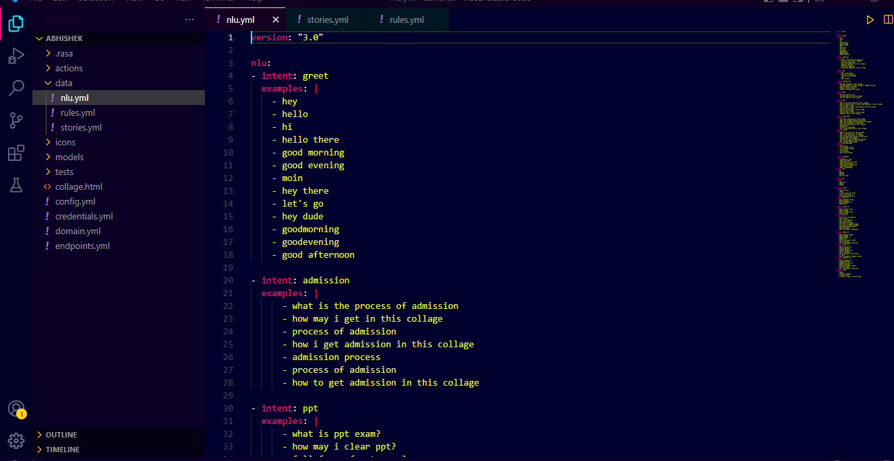

## 9.3. STORIES.yml:-

Stories.yml is a file that found inside the Data folder, as we have seen in **nlu.yml** where we specify the **intent,** in **Stories.yml** we specify **action ,** that if this intent occur then perform this action

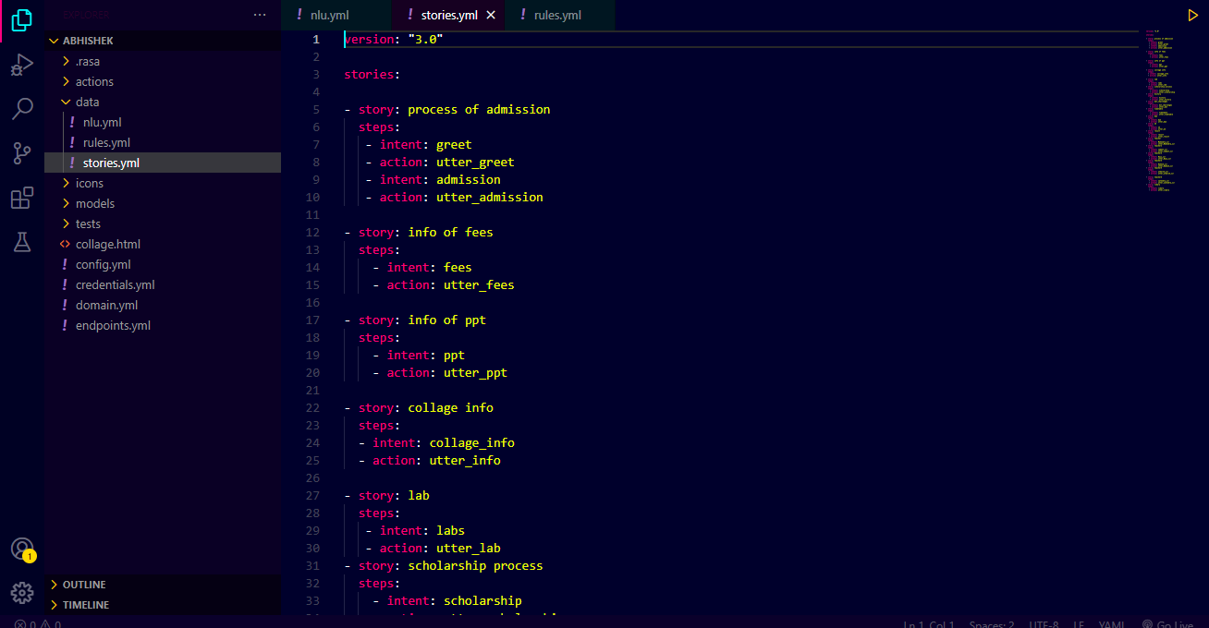

## 9.4. RULE.yml:-

Like Stories.yml Rule.yml also find in Data folder,in **Rule.yml** we define some Rules for bot like whenever user say Bye, **you immediately exit and says bye to him** and also whenever user asked who are you, **you should immediately tell them that Iam a Bot**

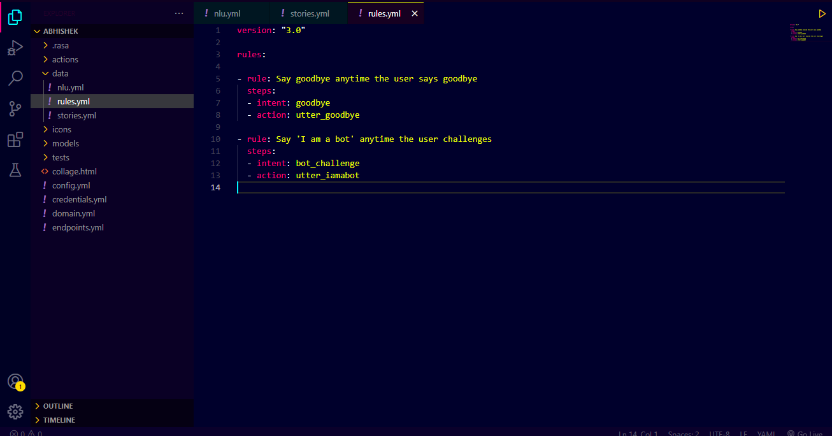

## 9.5. MODEl:-

Model is a folder where our Rasa model Store Whenever we train a model,it becomes store in this folder

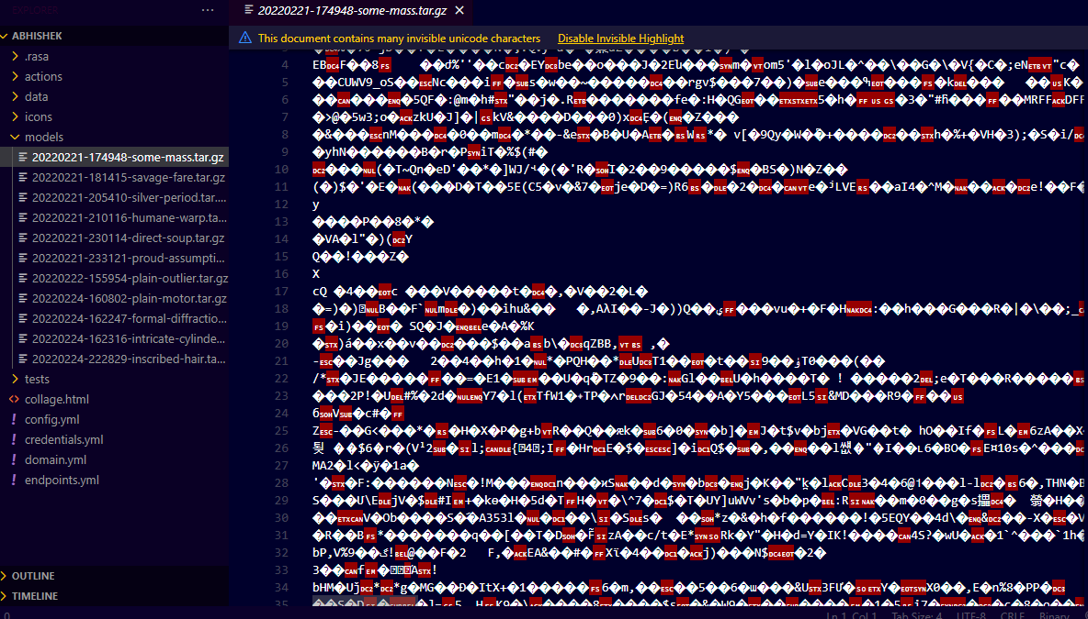

**Process of Traning Model:-**

Whenever we make a chatbot we need to train them it is similar to how we compile a program by creating it

To train bot we need to use a command “**Rasa Train”**

## 9.6. CONFIG.yml:-

If we talk about most important thing in rasa chat bot, it’s a config.yml because it have a **Pipeline**

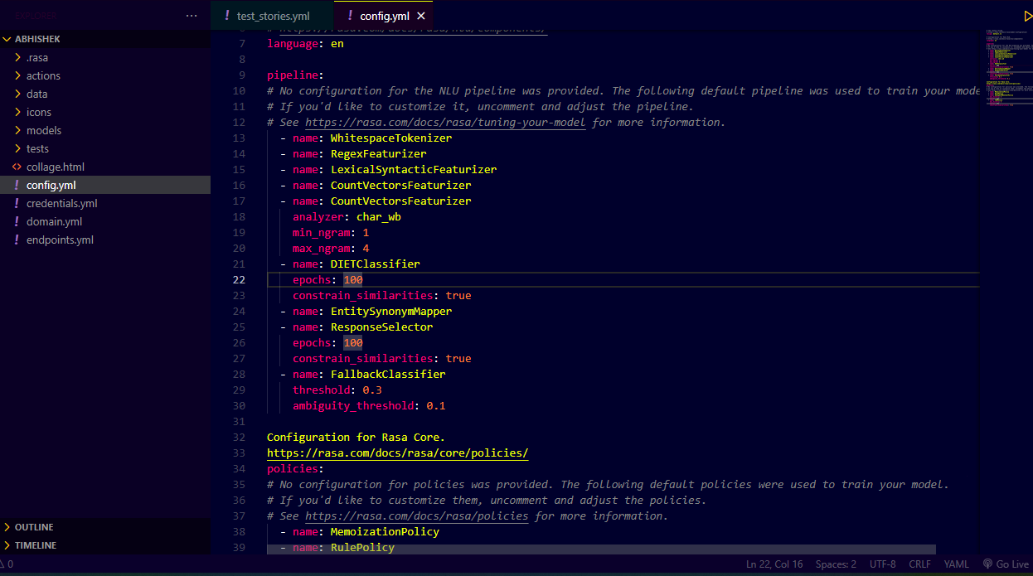

### 9.6.1 PIPELINE:-

The NLU pipeline defines the processing steps that convert unstructured user messages into intents and entities. It consists of a series of components, which can be configured and customised by developers.

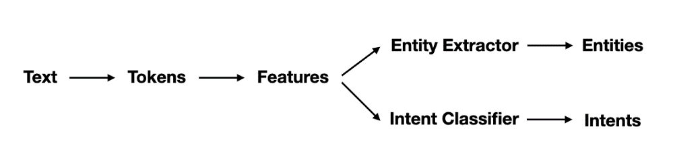

There are different types of components that you can expect to find in a pipeline. The main ones are:

1. Tokenizers
2. Featurizers
3. Intent Classifiers
4. Entity Extractors

### 9.6.2 Tokenizers:-

The first step is to split an utterance into smaller chunks of text, known as tokens. This must happen before text is featurized for machine learning, which is why you'll usually have a tokenizer listed first at the start of a pipeline.



**Details on Tokenizers.**

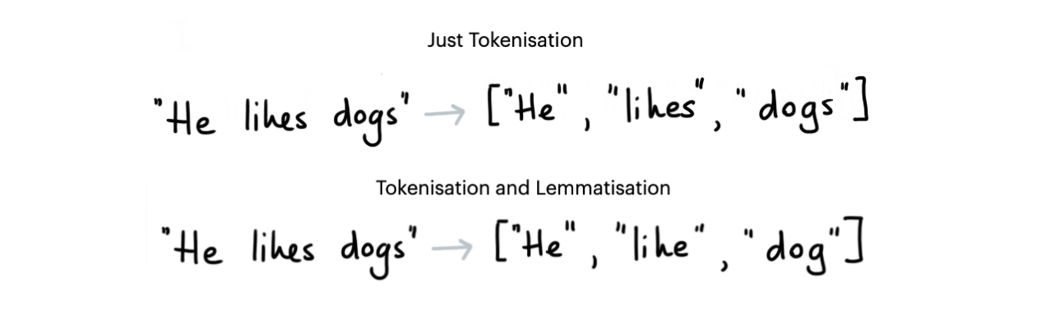

**Some tokenizers also add extra information to the tokens. For example, spaCy is able to also generate lemmas of the tokens which can later be used by the CountVectorizer.**

**The tokenizer splits each individual word in the utterance into a separate token, and commonly the output of the tokenizer is a list of words. We might also get separate tokens for punctuation depending on the tokenizer and the settings that we pass through.**

**For English, we usually use the WhiteSpaceTokenizer but for non-English it can be common to pick other ones. SpaCy is a good choice for non-English European languages but Rasa also supports Jieba for Chinese.**

**Note that tokenizers don't change the underlying text, they only separate text into tokens. That means, for example, that capitalisation remains untouched. It might be that you'd like to only encode the lower case text for your pipeline, but adding this kind of information is the job of a featurizer, which we'll discuss next.**

### 9.6.3 FEATURIZERS:-

Featurizers generate numeric features for machine learning models. The diagram below shows how the word "Hi" might be encoded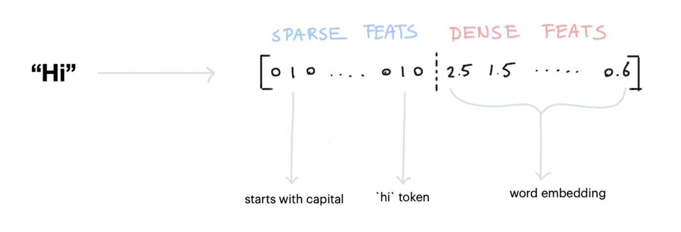

**There are two types of features:**

**Sparse Features:** usually generated by a CountVectorizer. Note that these counts may represent subwords as well. We also have a LexicalSyntacticFeaturizer that generates window-based features useful for entity recognition. When combined with spaCy, the LecticalSyntacticFeaturizer can be configured to also include part of speech features.

**Dense Features:** these consist of many pre-trained embeddings. Commonly from SpaCyFeaturizers or from huggingface via LanguageModelFeaturizers. If you want these to work, you should also include an appropriate tokenizer in your pipeline. More details are in the documentation.

### 9.6.4 Intent Classifiers:-

Once we've generated features for all of the tokens and for the entire sentence, we can pass it to an intent classification model. We recommend using Rasa's DIET model which can handle both intent classification as well as entity extraction. It isthe token- as well as sentence features

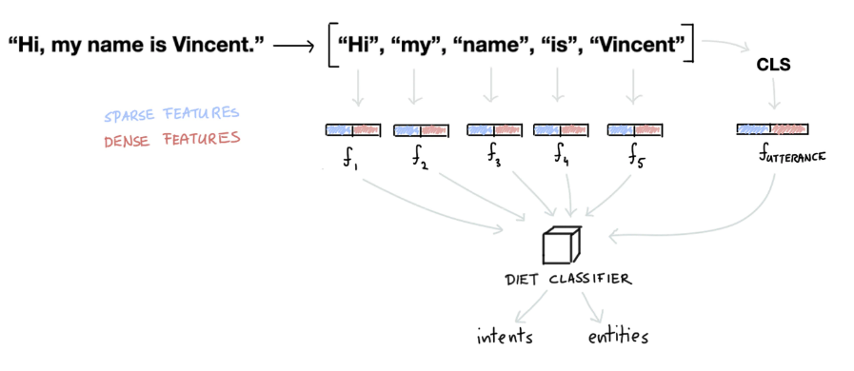

### 9.6.5 Entity Extraction:-

Even though DIET is capable of learning how to detect entities, we don't necessarily recommend using it for every type of entity out there. For example, entities that follow a structured pattern, like phone numbers, don't really need an algorithm to detect them. You can just handle it with a RegexEntityExtractor instead.

This is why it's common to have more than one type of entity extractor in the pipeline

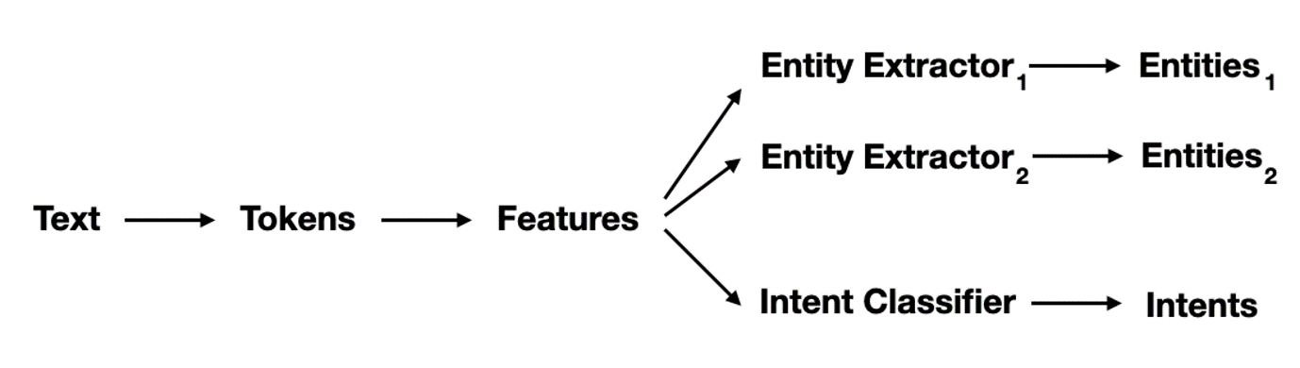

**Interaction: Message Passing:-**

As you can imagine, the components in a Rasa pipeline depend on each other. So you might be wondering how they interact.

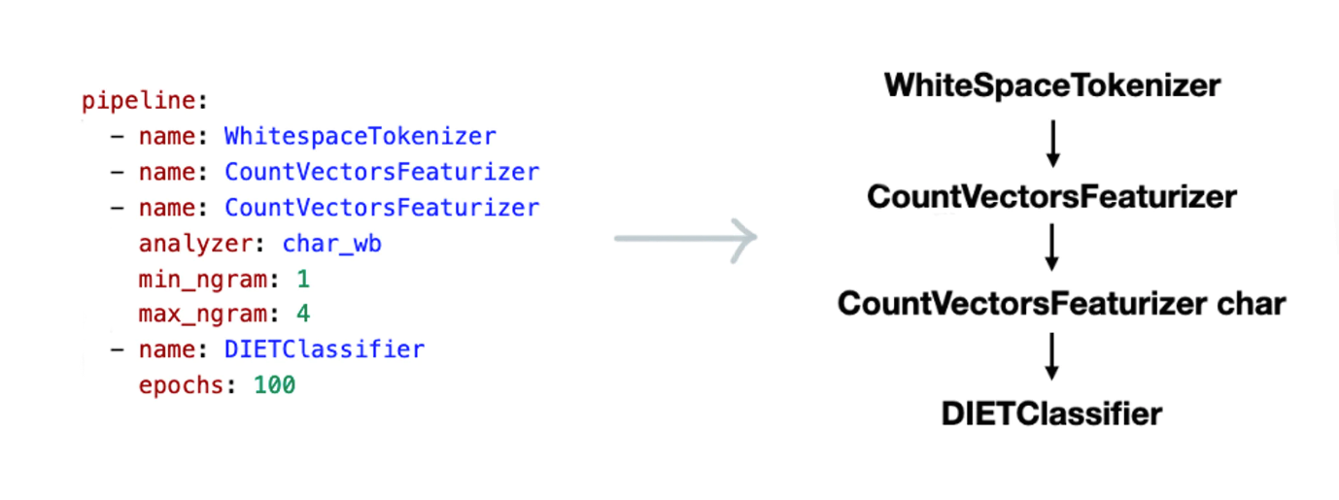

# 10. credentials.yml:-

Here things are related to server like in which port rasa chat bot will run,we need to specify port in which chatbot run like:- **Port:5005**

Here also we write program /code to link website,Whatspps,Teligram

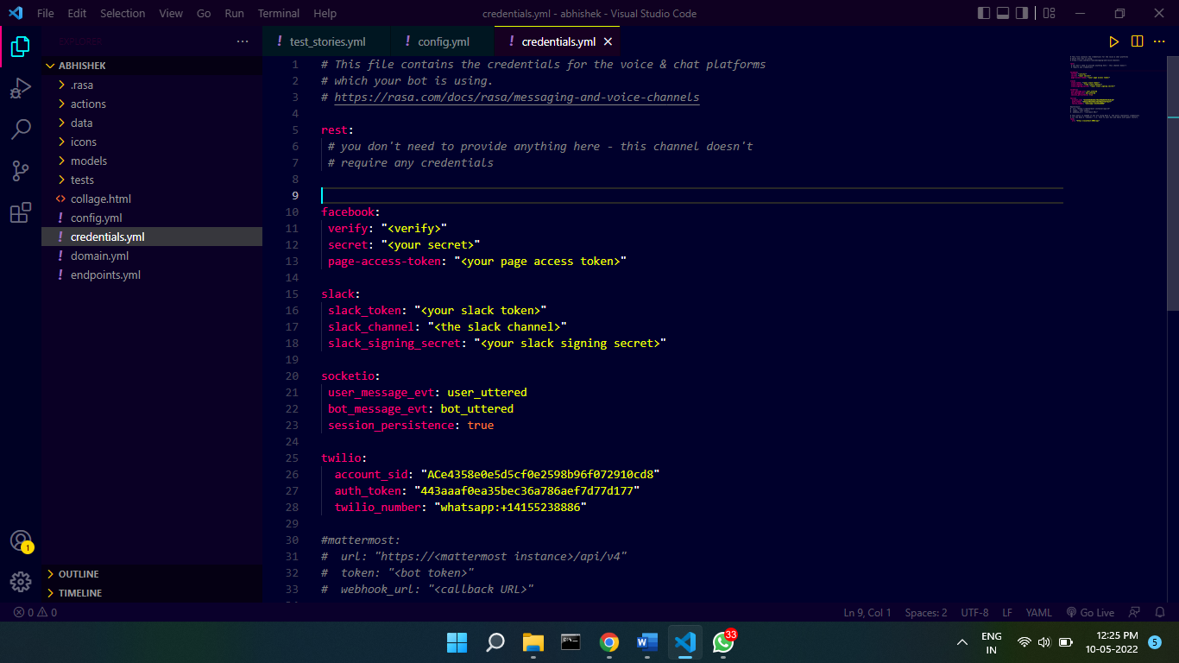

As you can see in the above image that there is **Facebook, Tillow** is connected to all these websites,To put chatbot in a **Website,Account,Server** we need to specify some things like **Acoount id**, **Number sever name ,autho Token**

# 11. Domain.yml:-

Domain.yml is a very importanat file. Eariler you saw in stories.yml that we used to classify actions, These are actions are written here

Here we have to write intent which we keep writing in nlu.yml. After that we have to write the actions for intent

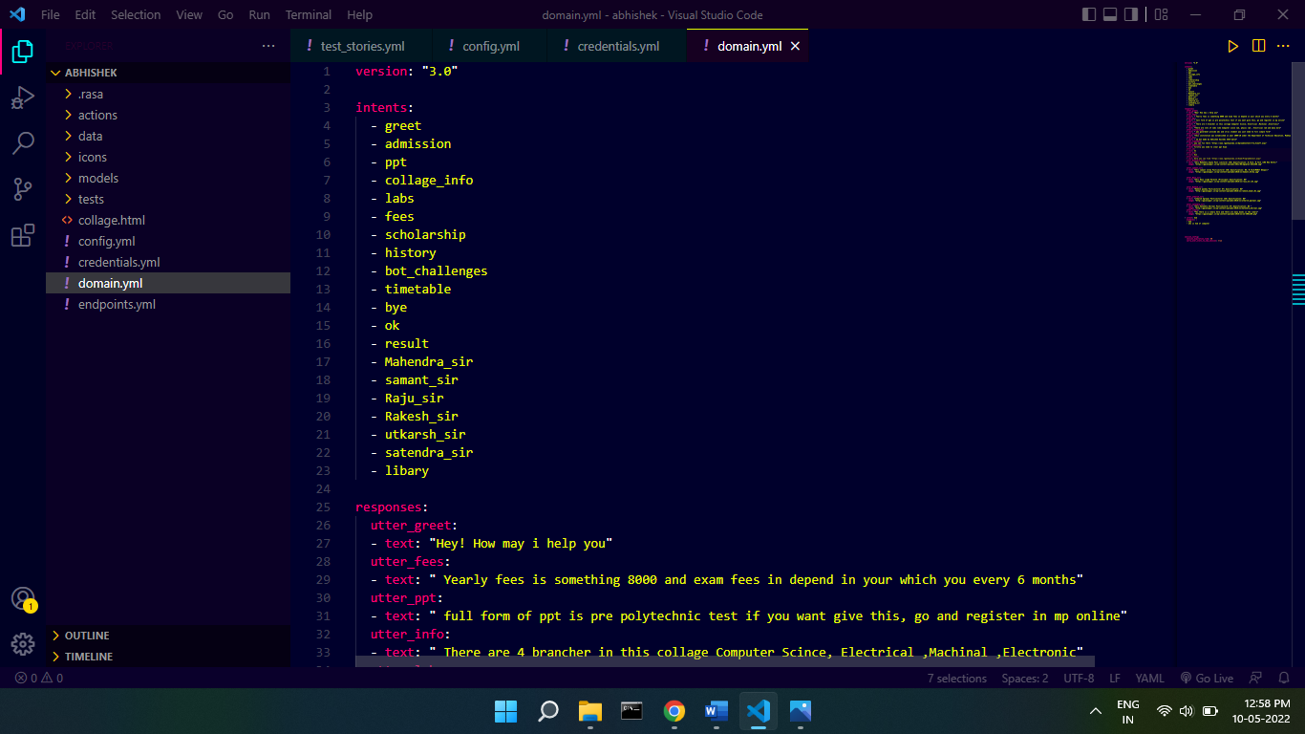

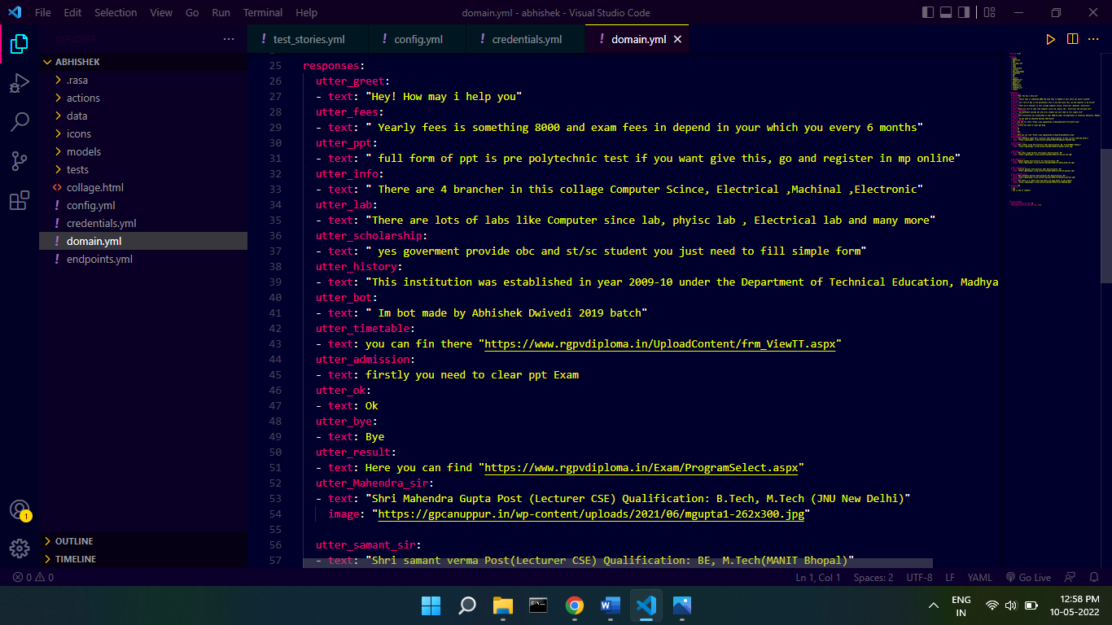

# 12. Process to Insert Chatbot in Website:-

To insert Rasa Chatbot in the website, you have to write some code of rasa chat bot in your **HTML** content .

It is written with the help of java script code

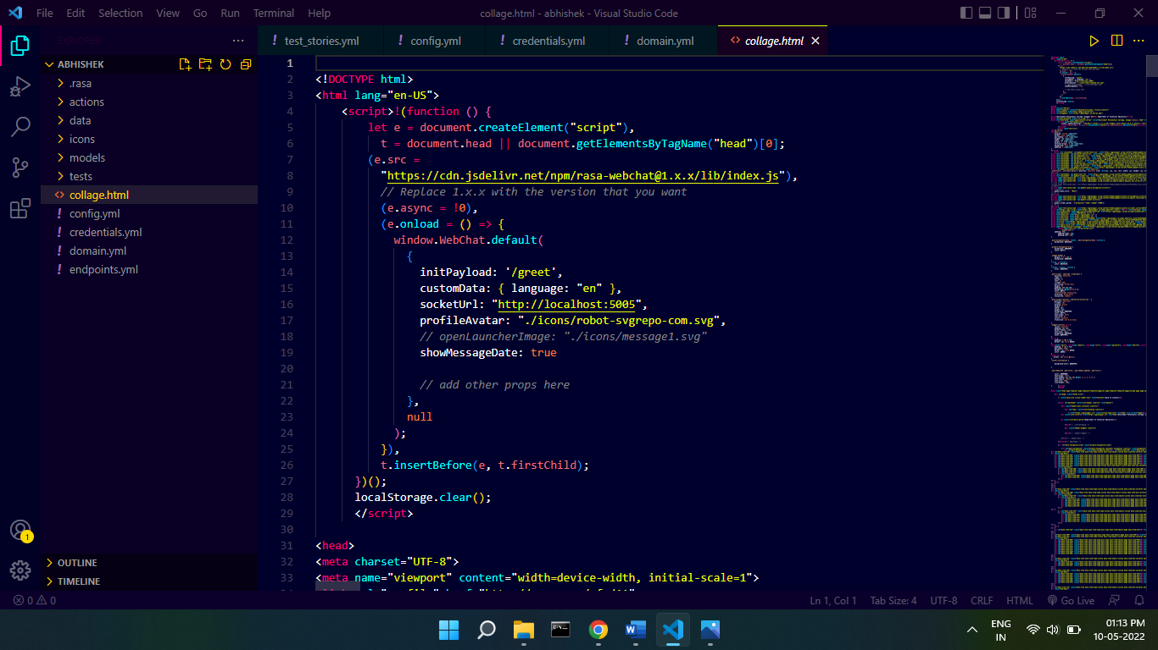

In this code we need to specify Socket Url is where your website is running if you’re your website in running on your Sever then you need to specify sever address / Domain name. If your website is not running in server then simply specify **LocalHost**

Also in this code there are **Payload,** you can understand payload in such a way that whenther the bot will say something automatically, or the user sends a message to him, then he will response

I specify Greeting intent in **Payload** in greeting intent there are some message like hii,hello,how are, goodmorning its means when ever user truns chatbot ,bot will message it self like:-

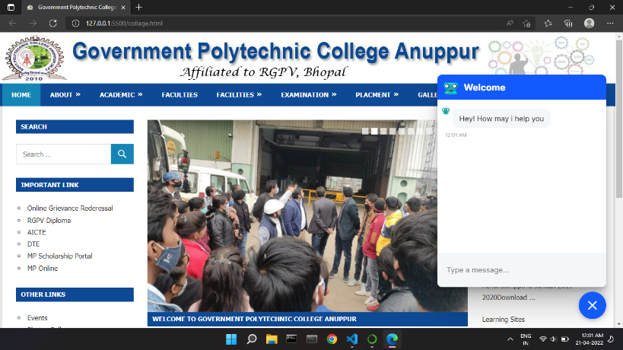

# 13. Process to make Whatsapp bot using rasa:-

If you don not have server then you need to use Thrid party sever and ng rok software , ng rock software are software that puts local host on internet

## Stpes to make Whats App Chat bot:-

***Step 1:-***  Create Account in Twilio, Twilio is a sever and also provedive whatapp bussiness Api

***Step2:-*** After ceating account , you have go to the **Message Section** then in the **Settings section** the **Whatspp sand Box settings**

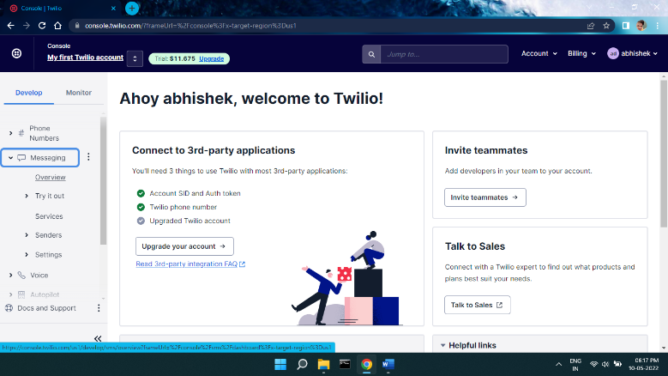

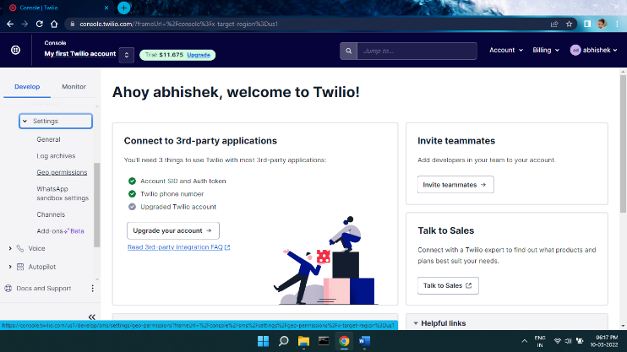

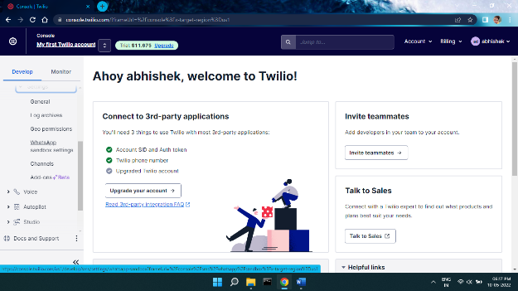

***Sept4:-*** When you reach here , you see like this Inter Face

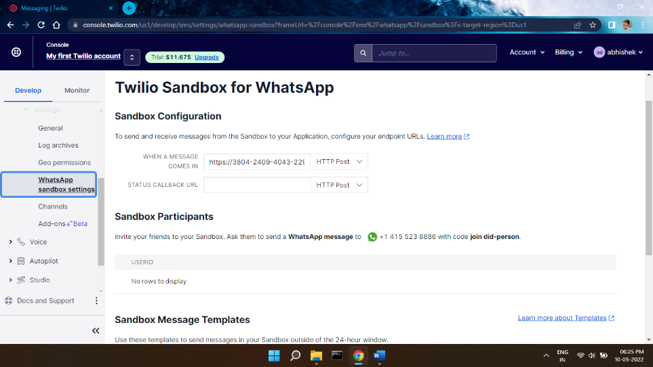

Here you can see a section **When a Message comes in,** here you have to enter the server link where your chat bot is running , because your botis running in local host then you need help of ng ng rok to put localhost in the internet

***Step5:-*** But before doing all this, you have to tell rasa chatbot that on which number it will have to be activated or not and which server it will run

Earlier I told you about **credential.yml** where things realted to server are written here you have to **specify SID**, **Authorize Token**, and **Tiwlio number** if you do not have Whats App bussines api, if you have then Simpely past it

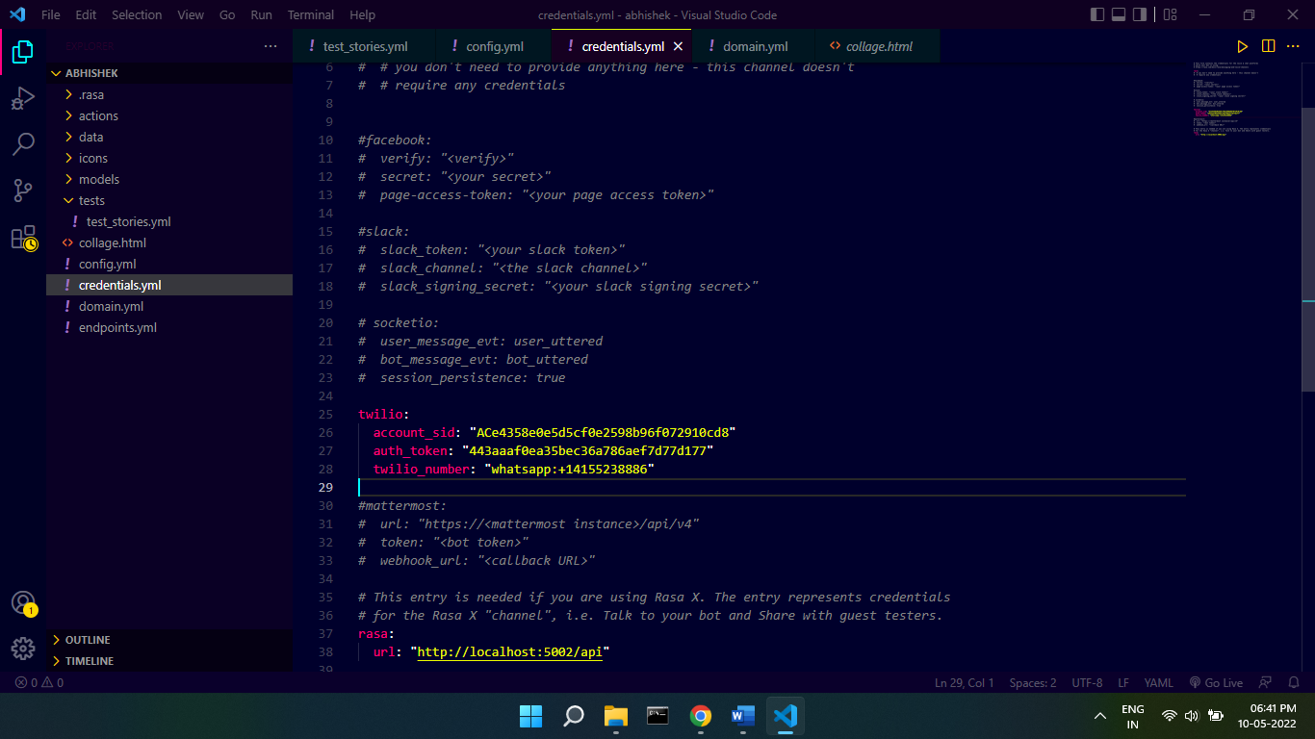

***Step6:-***  Afterdoing all this you simply have to train your rasa model one more time so that he know every thing

***Step7:-*** After doing all this, you just have to type a simple command ,so that your rasa chat bot starts running like this

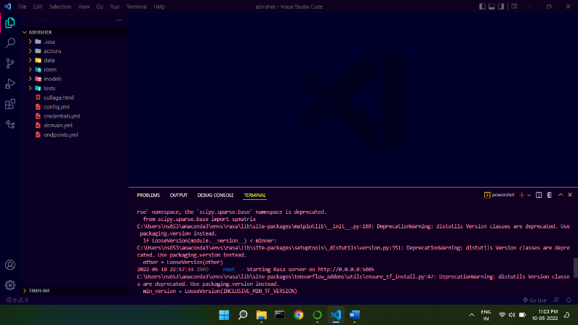

***Step8:-*** After that you have to put port in which rasa chat bot is running like this

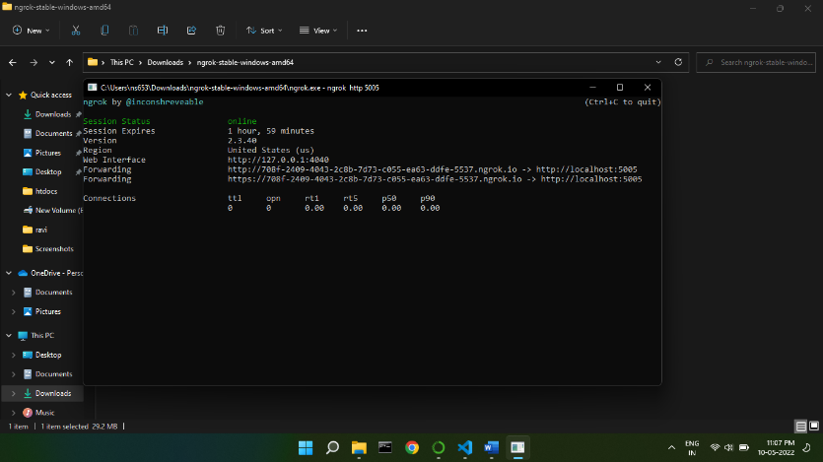

***Step9:-*** As you can see , here after specifying the port we get link we have to put this link in Tiwlio

After that we need to type small command then after our bot start given response like that:-

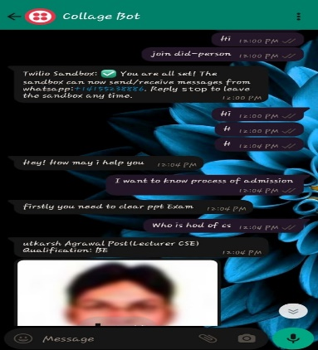

# 14. REFERENCES: -

[1]For web site <https://youtu.be/eJMT2FovZsM>

[2]For whatapp chatbot <https://youtu.be/K7boxP8Q50M>

[3] Pipeline <https://rasa.com/blog/intents-entities-understanding-the-rasa-nlu-pipeline/>

[4] What is Rasa <https://rasa.com/>